DEPARTMENT OF THE ARMY
THE U.S. ARMY cENTER OF MILITARY HISTORY
102 4th AVENUE
FORT LESLEY J. McNAIR, DC 20319-5060
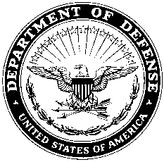

AAMH-MD XX XXX XXXX

MEMORANDUM FOR Director, _____________ Museum, _Address_____________

SUBJECT: Approval to exception to policy for volunteer

1. Reference:

a. Memorandum, Name of Director, Date, Subject: Volunteer Exception to Policy.

b. AR 870-20, Army Museums, Historical Artifacts and Art, 11 January 1999, Paragraph 3-12, Volunteer Programs.

2. Request for exception to policy authorizing Name of Volunteer to work as a volunteer at the _______________ Museum from Dates from-to is approved.

3. Name of volunteer is approved to work with the museum’s historical artifacts under the direct supervision of an assigned museum staff member; and be granted access to AHCAS.

4. The POC for this action is Ms. Ginger Shaw, Chief, Field Museums Branch, 202-685-2462 or email: Virginia.k.shaw.civ@mail.mil.

RICHARD W. STEWART, Ph.D.
Director, Center of Military History

