Imaginary lines on a globe that show distance from the equator.

Latitude=

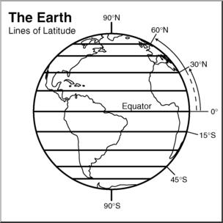

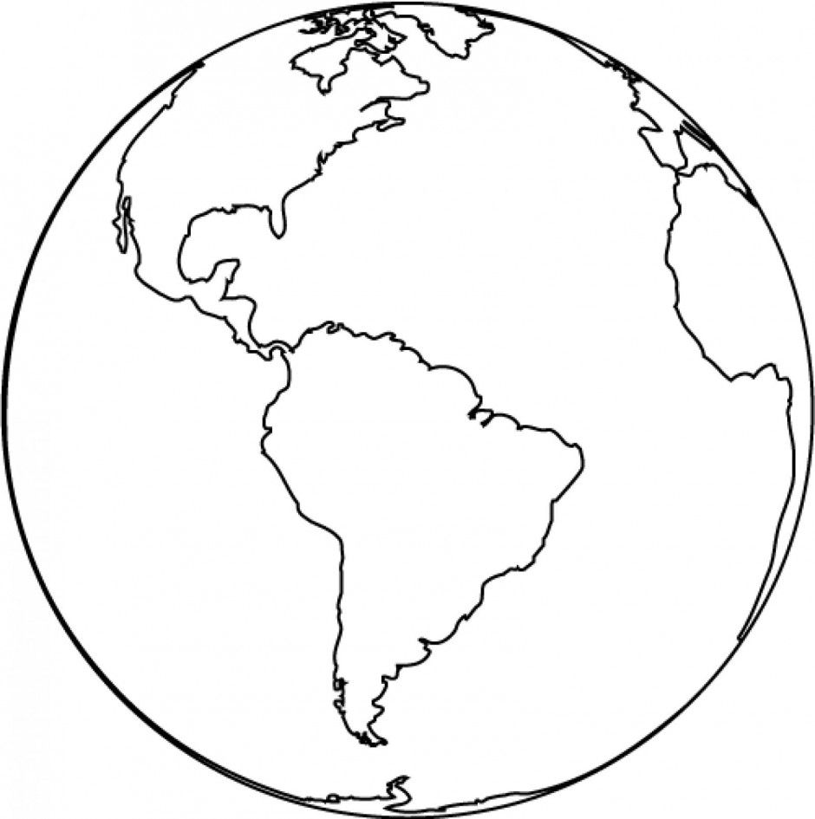

1. Draw lines of latitude on the globe to the right. Use a ruler to get straight lines.
2. Color your globe!

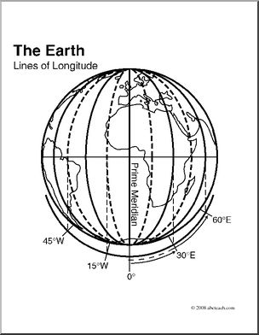

Imaginary lines on a globe that show distance from the Prime Meridian.

Longitude=

1. Draw lines of longitude on the globe to the right.
2. Color your globe!