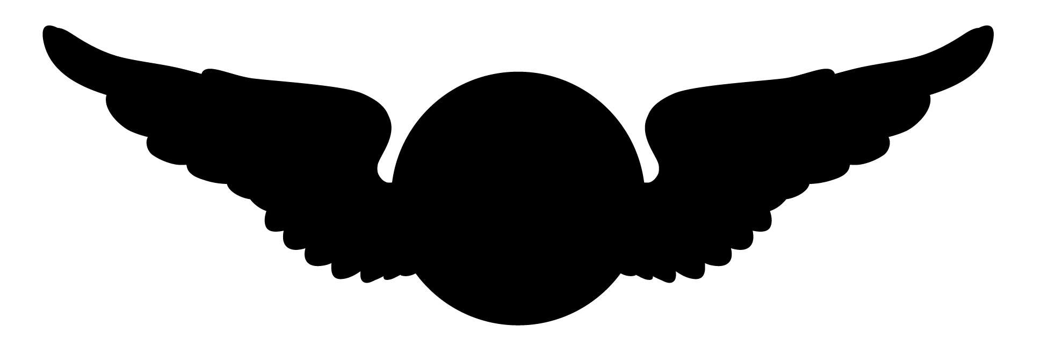
Early Military Flight
The Military’s First Drones

The military’s first type of drone, or aerial observation vehicle was the balloon. Balloons were first used during the Civil War (1861-1865) by both Union and Confederate forces to spy, observe, and direct artillery fire. Later in 1907 experiments with dirigibles began. Dirigibles were similar to balloons but were longer in shape and were propelled by gasoline engines. Just after the dirigible was introduced many inventors presented their versions of the aeroplane and in 1909 the military purchased the Wright Brothers Military Flyer.
From this….

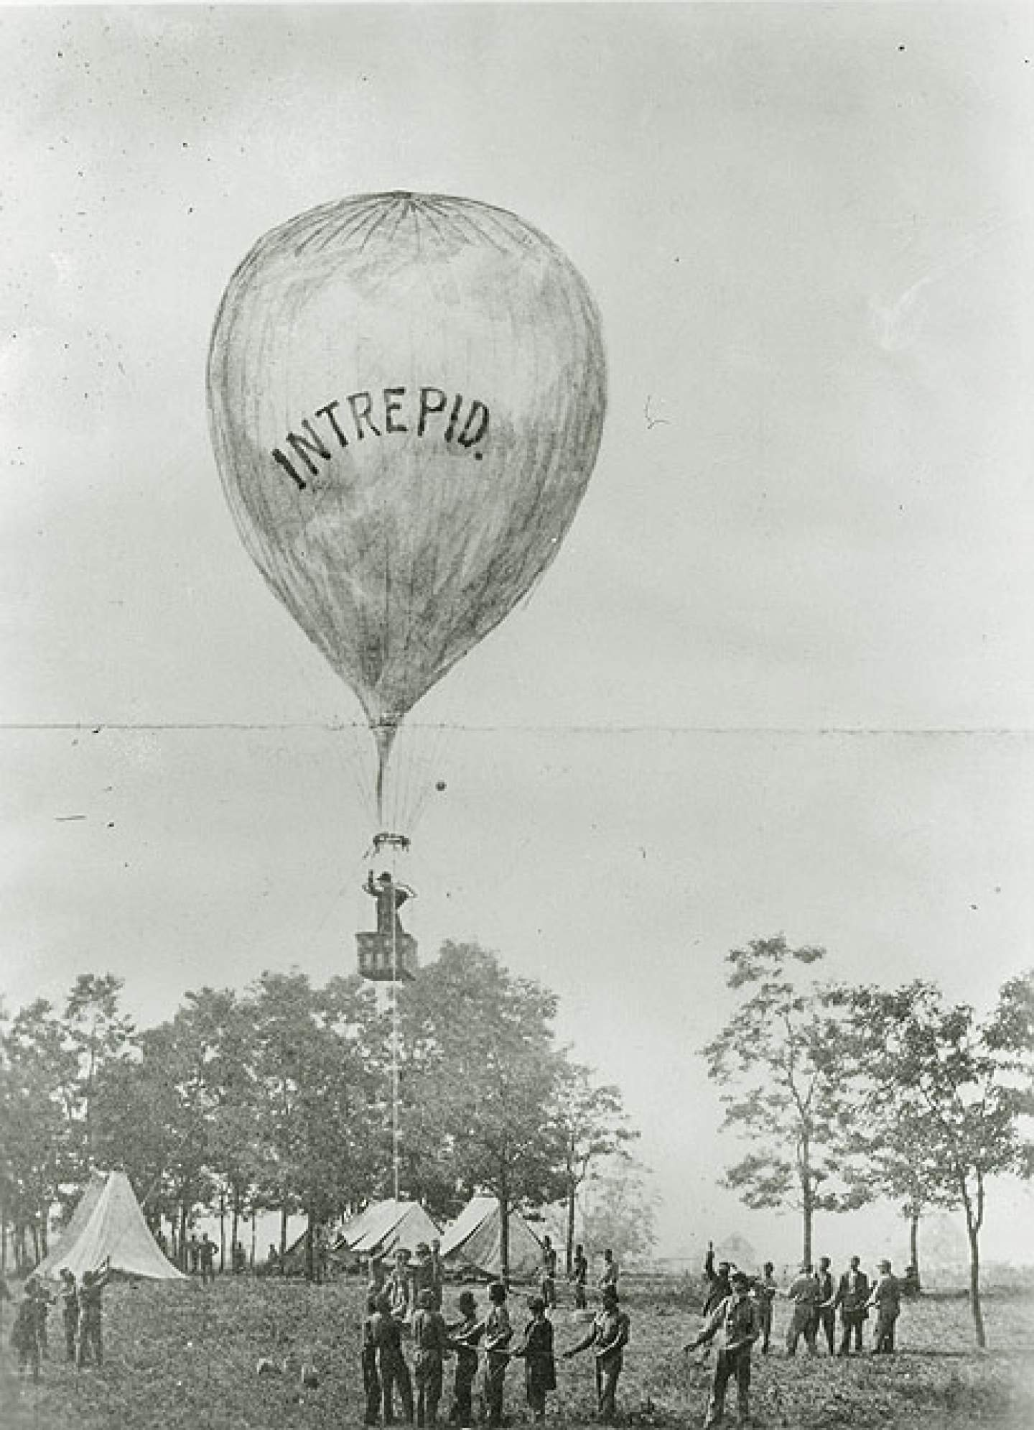
To this

The Aeronauts and Balloons- Lighter Than Air Craft

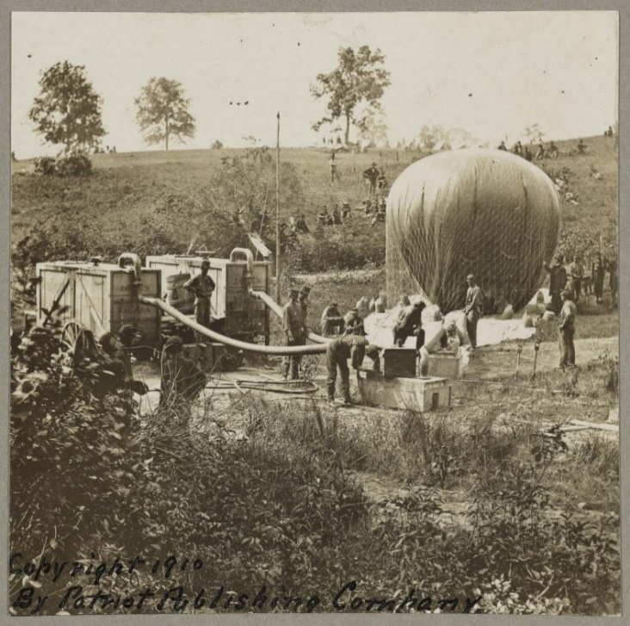
Civilians and eventually soldiers who flew balloons were called aeronauts. Most aeronauts started ballooning in carnivals or shows and in academia. Thaddeus Lowe and John La Mountain combined ballooning into entertainment and experiments. They both offered the use of their balloon to the Union Army for aerial observation.
Balloons were filled with hydrogen gas and were attached to a basket that held the aeronauts. The aeronauts flew the balloons in free flights and tethered flights. Free flights were tricky because wind direction changed with altitude and it was possible to drift into enemy territory. It was difficult to steer or navigate because of the unpredictable wind. The aeronauts ascended by emptying 100 lbs. sand bags from the basket and descended by releasing hydrogen from the balloon. The preferred method for aerial observation was tethered flights in which the balloon was attached to the ground with long ropes that kept the balloon from drifting away. Tethered flights were tricky too because it took a team of about 30 soldiers to raise and lower the balloon who could also be under the threat of enemy fire during launches and descents. Tethered flights improved observation of the enemy, but it also gave away ones position.
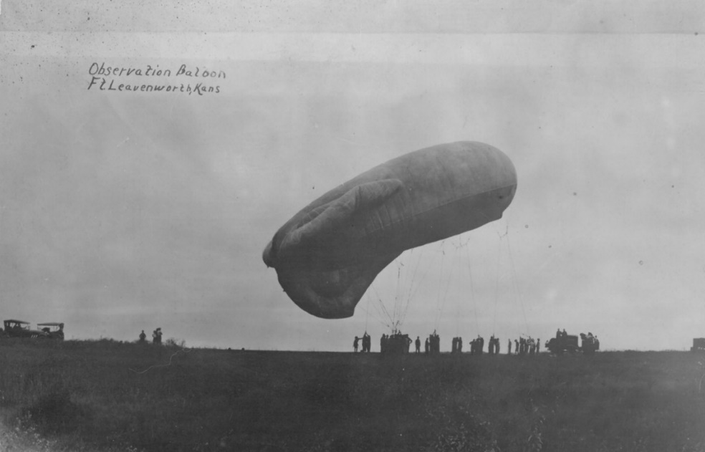
The Balloon Corps
The civilian led balloon corps began in 1861 with the Union Army during the Civil War with the guidance of Thaddeus Lowe. It was later disbanded in 1863 but reinstated in 1892 with the onset of the Spanish American War. Ballooning became somewhat of a hobby or sport after the Spanish American War. It was not until 1905 that the military looked at balloons again. The Aero Club of American held many balloon shows and races that reignited the Signal Corps’ interest in ballooning for military use. The Chief Signal Officer ordered a new spherical balloon in 1906 which was only the 10th purchased by the Army since the Civil War.
This is an observation balloon flown at Fort Leavenworth, KS. It dates to about 1900. Balloons were first made in spherical shapes, but later other shapes, like this elongated balloon, were introduced.
Activity #1
What do you think was the significance of the balloon shape?

Activity # 2
Sketch your own design for a balloon. What shape will it be, how will it fly, and how will it be piloted?

Activity #3
What do you think were pros and cons of the military using balloons?
Dirigibles- Lighter Than Air Craft

What is a Dirigible?
A dirigible is a self-propelled lighter-than-air craft. It has a cigar shaped balloon that is filled with gas (hydrogen or helium), a long car beneath the balloon that holds the aeronauts or crew, an engines to power the propellers, and both horizontal and vertical rudders to help steer it. Unlike balloons, dirigibles could be steered and were propelled by gasoline engines. Although dirigibles were constructed in Europe since the 1850s the U.S. military did not consider using dirigibles until 1907 when funds were accrued to obtain an experimental dirigible balloon for the Signal Corps. The Army purchased a dirigible created by Thomas Baldwin and named it U.S. Army Dirigible Balloon No. 1. The Army continued to experiment with dirigibles, but the lighter than aircraft were overshadowed a few years later by the appearance of heavier than aircraft, also known as the airplane.

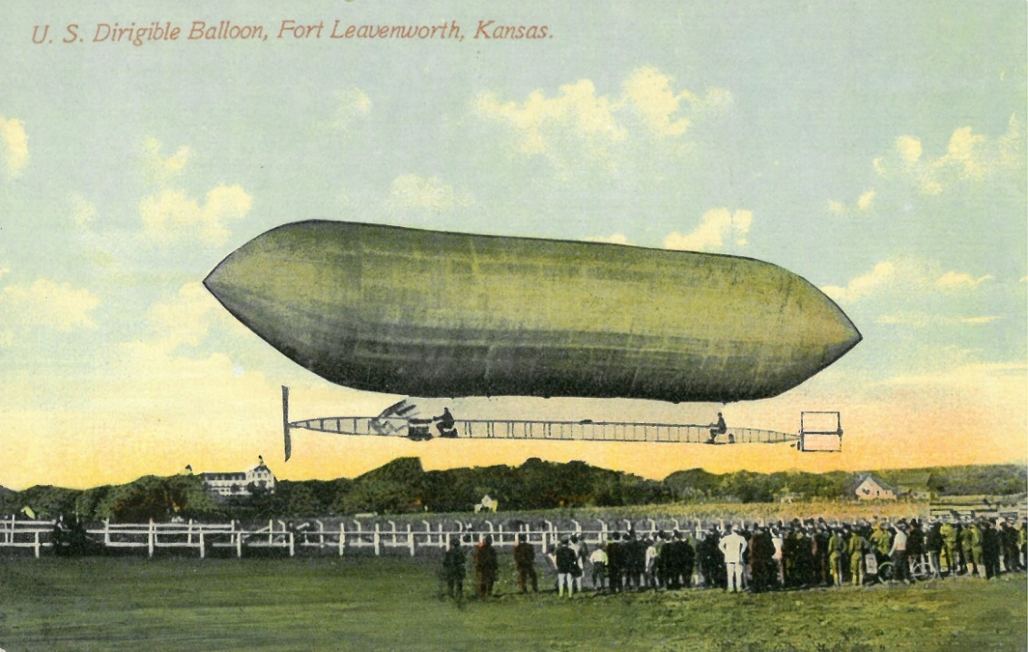

Technology in the Air: Photography and Telegraphy
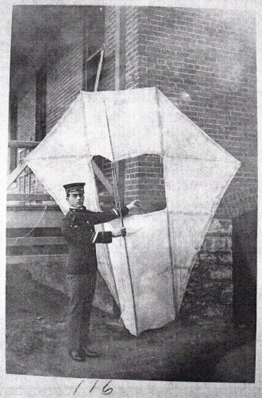
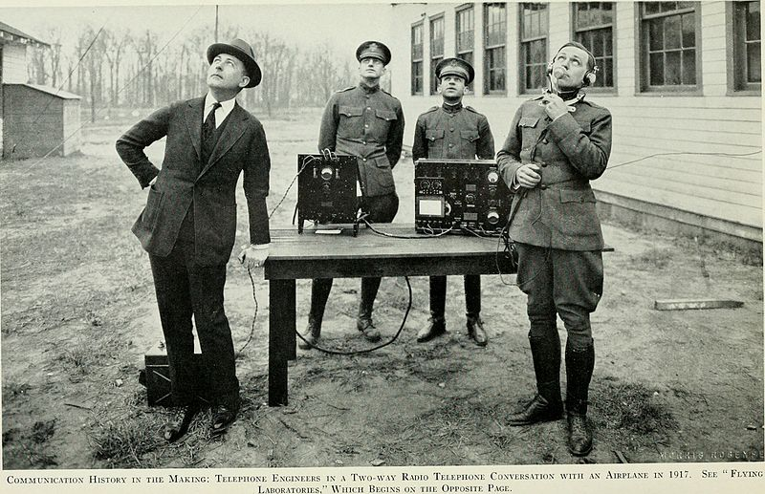
Once the Army was in the air, soldiers needed to train not just in flying balloons and dirigibles, but with other technology while in the air; photography and telegraphy. Balloon training included map reading, charting enemy installations, observing troop movements, and refining methods of relaying information. Photography in balloons was very awkward due to so much movement of the balloon. Efforts, therefore, changed to telegraphic communication, also known as the radio. Getting equipment high enough was key to receiving and sending sound waves. Before balloons came into the picture the Signal Corps first experimented with kites. Just like with kites, balloons had a telephone line that ran from the basket to a switchboard system on the ground that allowed observers to send codes that could, for example, direct artillery battery toward enemy lines. Wireless telegraphy, or the use of radio waves became a big part of balloon, dirigible, and eventually airplane training. It also allowed for more flexibility in communication by eliminating the restrictive wires. Balloon training with wireless telegraphy continued through WWI.

King Kite used for telegraphy, Fort Leavenworth, 1905
Telephone engineers in two-way radio telephone conversation with an airplane 1917. Image courtesy of Bell Telephone Magazine
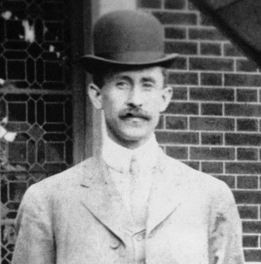
The Airplane

In 1909 the Army purchased its first airplane, known as the Military Flyer. It was built to Army specifications by the Wright Brothers from Dayton, OH. Experimentation and manufacturing of various airplanes increased in the early 1900s. The Army was anxious to purchase an airplane for future military use because international crisis brought the need for technological innovation and other countries were already forming aerial fleets, France and Germany being in the lead. In 1908 the U.S. military received 41 bids from various inventors for a military airplane. Only three were considered; Mr. J.F. Scott from Chicago, Mr. AM. Herring from New York City, and the Wright Brothers from Dayton, OH. The Army had a list of requirements that had to be accomplished before making their decision. The Wright Brothers’ Military Flyer checked them all off the list.
Army Airplane Requirements 1908:
- Reach a speed of 36 miles per hour
- Capable of carrying 2 people whose combined weight equal 350 lbs
- Carry additional weight of sufficient fuel for a non-stop flight of 125 miles
- Controllable in any direction
- Endurance flight of 1 hour
- Land at its take-off point without damage so the flight can resume immediately
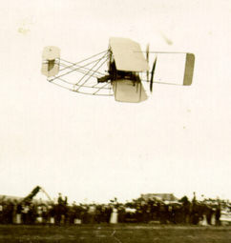

Image courtesy of wright-brothers.org
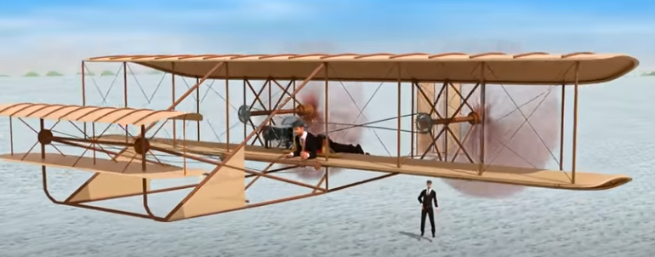
Watch this video to learn about the technology and engineering it took to fly one of the Wright Brother’s airplanes.

The Brilliant Engineering of First Flight!
(https://www.youtube.com/watch?v=LigpsX1KoQE)

*video created by Learn Engineering
Military Flyer Specifications

- 36.5 ft (11.1 m) wingspan

- 5.8 ft (177 cm) chord

- 5 ft (152 cm) separation

- 415 sq ft (38.6 sq. m) wing area

- 1:20 camber

- 80 sq ft (7.4 sq m) double horizontal front rudder

- 16 sq ft (1.5 sq m) twin movable vertical rear rudders

- 28.9 ft (8.8 m) overall length

- 735 lb (333.4 kg) total weight (without pilot)

- Wright 4 cylinder water cooled inline engine, 32 horse power at 1310 rpm

- Two contra-rotating propellers, 9 ft (274 cm) long, turning at 425 rpm

- 42 mph (67.6 kph) average speed

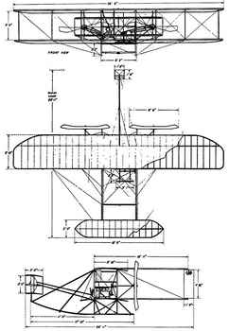

Image courtesy of wright-brothers.org
Activity #4
From the video above and your own research, find the significance of each specification listed above. What do each of these do for the airplane? Write your answer next to each specification.
The Fight For Flight

Two major figures associated with early flight in the military were Billy Mitchell and Benjamin Foulois. These two men were both in the military, completed similar studies, and were both involved with early flight efforts. In the early part of the 20th century any activity the Army did in terms of aeronautics or flight fell under the Signal Corps, but in 1913 Congress tried to decide whether there should be an Army aviation corps that would be separate from the Signal Corps. The proposed legislation was H.R. 28728. Mitchell and Foulois would disagreed on what to do about Army aviation.

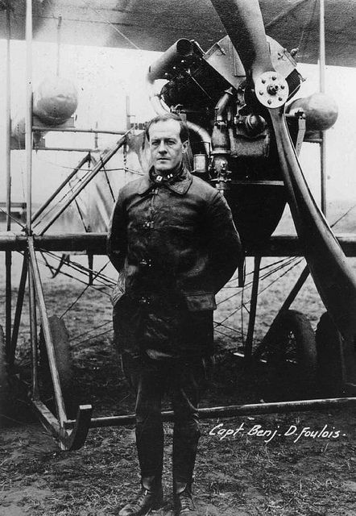
Two major figures associated with early flight in the military were Billy Mitchell and Benjamin Foulois. These two men were both in the military, completed similar studies, and were both involved with early flight efforts. In the early part of the 20th century any activity the Army did in terms of aeronautics or flight fell under the Signal Corps, but in 1913 Congress tried to decide whether there should be an Army aviation corps that would be separate from the Signal Corps. The proposed legislation was H.R. 28728. Mitchell and Foulois would disagreed on what to do about Army aviation.
MG Benjamin Foulois
Foulois thought congressional legislation for an independent aviation corps was premature and not well thought out. He did see the future of military flight, but was skeptical the Army was ready to establish it officially on its own.

MG Benjamin Foulois
Foulois thought congressional legislation for an independent aviation corps was premature and not well thought out. He did see the future of military flight, but was skeptical the Army was ready to establish it officially on its own.
General William (Billy) Mitchell
In the beginning Mitchell did not disagree with Foulois about what to do with Army aviation, his disagreement came years later when he was assigned as commander of Army Aviation (still under the Signal Corps). In 1917 he studied aircraft in France and was promoted to Brigadier General when the U.S. declared war on Germany. He was placed in charge of all the American aerial combat units in France. He successfully in demonstrated what air power could do by attacking across German lines to destroy their ground power by air. After this he became very vocal in his views to strengthen air power in the U.S. In his fight to do this he was court martialed due to his brash comments about his superiors not taking enough action to promote and support military flight efforts; he resigned from the military.

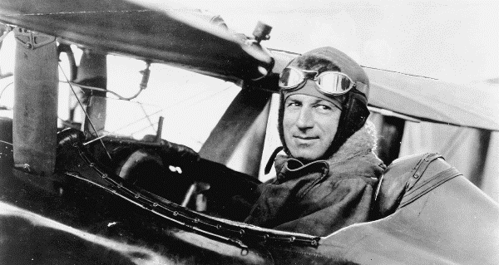
General William (Billy Mitchell)
In the beginning Mitchell did not disagree with Foulois about what to do with Army aviation, his disagreement came years later when he was assigned as commander of Army Aviation (still under the Signal Corps). In 1917 he studied aircraft in France and was promoted to Brigadier General when the U.S. declared war on Germany. He was placed in charge of all the American aerial combat units in France. He successfully in demonstrated what air power could do by attacking across German lines to destroy their ground power by air. After this he became very vocal in his views to strengthen air power in the U.S. In his fight to do this he was court martialed due to his brash comments about his superiors not taking enough action to promote and support military flight efforts; he resigned from the military.
Activity #5
Who would you side with on what to do about Army aviation, Benjamin Foulois or Billy Mitchell? Why? Conduct more research if needed.

Things to consider:
- Dirigibles were still being used by the Signal School and soldiers were being trained to fly dirigibles and balloons at Fort Omaha, NB
- Toward the beginning of 1913 the Signal School purchased eleven planes.
- In Nov. 1913 artillery fire had been directed from an airplane for the first time, by Hap Arnold. He also set an Army altitude record of 4,674 feet.
- The first Army air school was opened in the Philippines and was commanded by Lieutenant Frank Lahm with a one-plane training squadron.
- France, Germany, and England were advancing with aviation accomplishments and establishments.
- There were very few experienced pilots at this time.
- Concepts of how airplanes should be used to support ground troops was still being formed along with logistical organization.
- There was an issue with whether to give aviation soldiers hazard pay due the dangers of flying.
- Six Army men had died by the end of 1912 and along with many civilians from crashes that resulted from experimental flight. Seven more crashes occurred in 1913.

