What Did Seaman Hear?

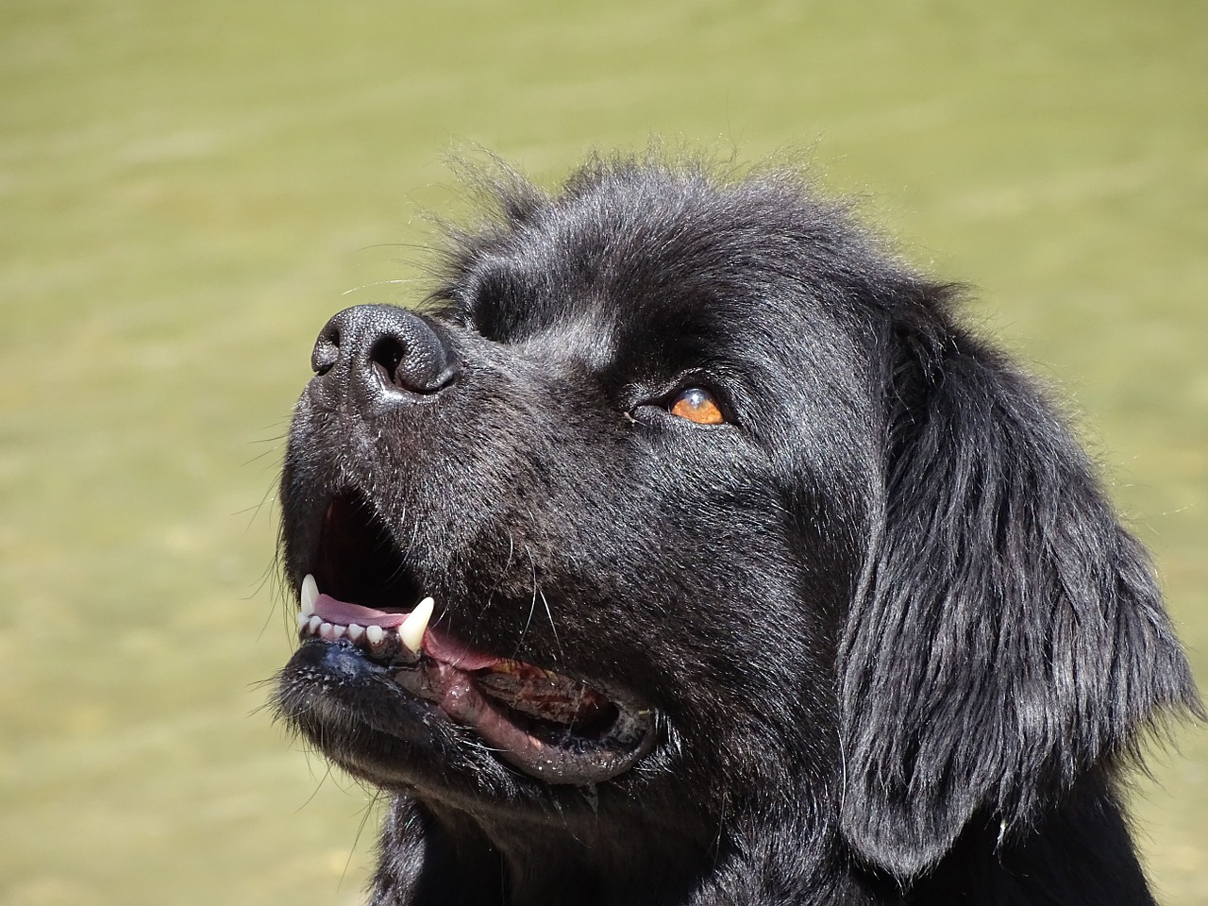

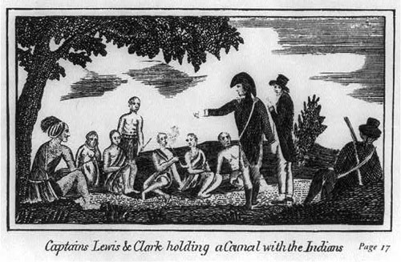

**Peace Talks**

A big part of the expedition was to study and have peace talks with Native American tribes. President Thomas Jefferson instructed Lewis and Clark to have meetings with Chiefs of each tribe they met. Seaman heard many different Native American Languages that included the Plains tribes; Osage, Sioux, Cheyenne, Crow, Mandan and thePlateau tribes; Blackfeet, Flathead, Shoshone, Nez Perce, Spokane, and Yakima. Seaman heard Lewis and Clark speak with the Native Americans, letting them know that they came in peace. It was important to have these peace talks because Lewis and Clark were hopeful that this could lead to trade with Native American tribes and to avoid conflict.

Although I couldn’t speak I still played a part in the peace talks. Lewis liked to show me off and the Native Americans were fascinated by me, they thought I looked like a small bear with floppy ears and a wagging tail! This brought a sense of ease and playfulness to the meetings.

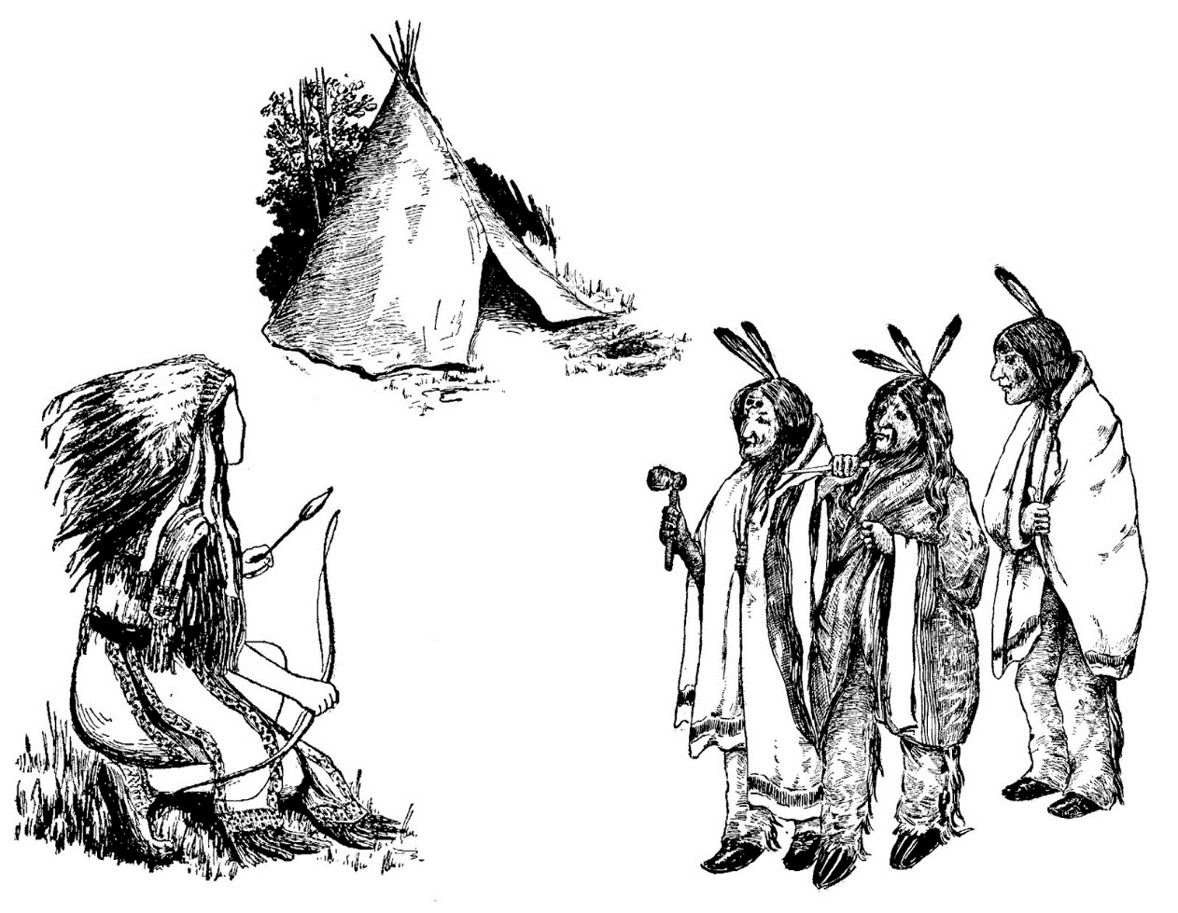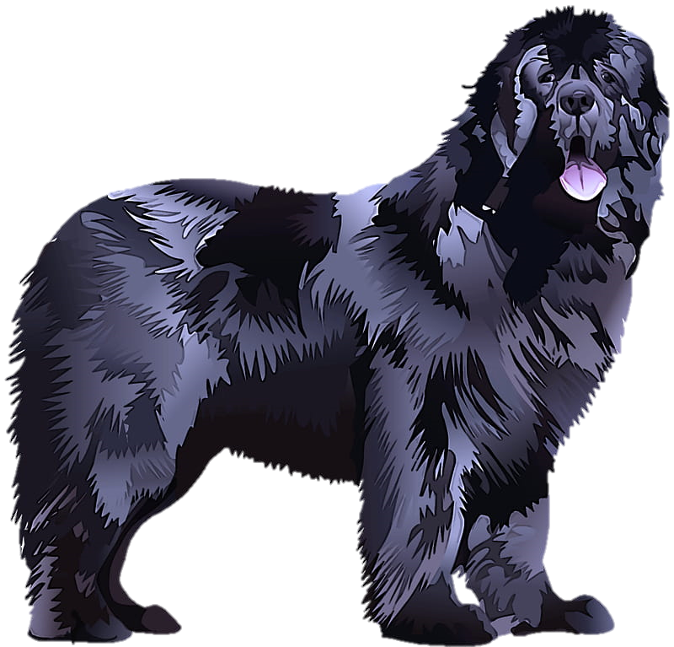

Gifts for the Native American Tribes

Lewis and Clark packed gifts for the Native American tribes they met on the journey. These gift included pipe tomahawks, sheet iron, flannel, handkerchiefs, combs, cloth, beads, butcher knives, pocket looking glasses, ribbon, bells, needle cases, lockets, earrings, rings, and corn mills. Lewis and Clark also gave more than 80 Jefferson peace medals to chiefs they encountered on their expedition. The medals had an image of President Jefferson on one side and a tomahawk, pipe, and clasped hand on the other to represent a peaceful relationship between the Native Americans and white men.

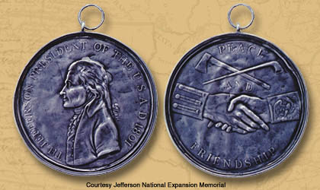

**Danger**

For a dog scent and sound carry messages to their brains, something humans cannot always do. Seaman could hear if something dangerous was approaching the travelers.

Many times I alerted Lewis and Clark when a bear or buffalo was approaching our camp and I chased them off! One night a buffalo ran toward our camp while everyone was asleep. I barked and growled at it and made it turn away from our camp.



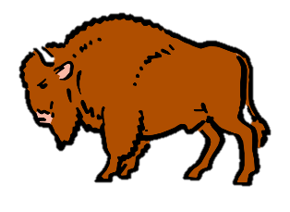

**Nature Activity**

Seaman heard the many sounds of nature such as the sound of rivers, rain, wind, other animals, and insects.

Step outside what do you hear? Record what you hear in your journal.