What Did Seaman See?

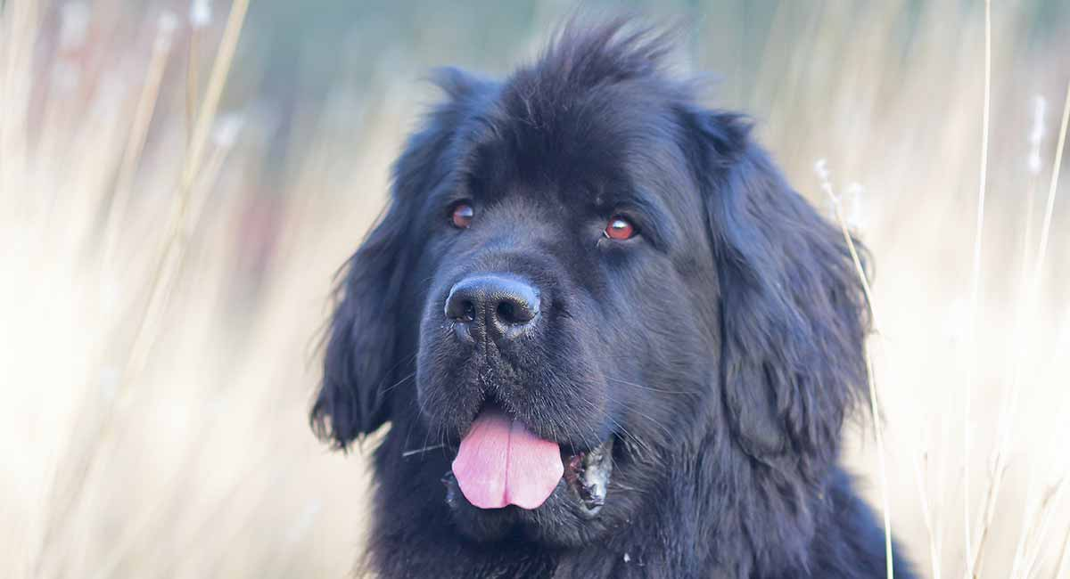

Native Americans

The Corps of Discovery encountered many different Native American tribes that included Plains tribes; Osage, Sioux, Cheyenne, Crow, Mandan and thePlateau tribes; Blackfeet, Flathead, Shoshone, Nez Perce, Spokane, and Yakima. Some were friendly and some were not.

We had a Native American travel with us on our journey, her name is Sacagawea. She was Shoshone and who was married to another member of the expedition who both served as interpreters and helped us communicate with Native American tribes. Sacagawea was also the only woman to travel with us. She helped us a lot by finding edible plants, saving supplies when our boats tipped over, and making sure we had peaceful meetings with not only her Shoshone tribe but other tribes too. She played a big part in getting horses from the Shoshones for us to travel on land.

On our return journey a group of Native American stole me from my traveling party! Lewis sent three armed men to come and save me, they scared away the Native Americans and brought me back safely. Some tribes we met were very friendly and we exchanged gifts with them, some were not friendly because they did not trust outsiders coming to their land.

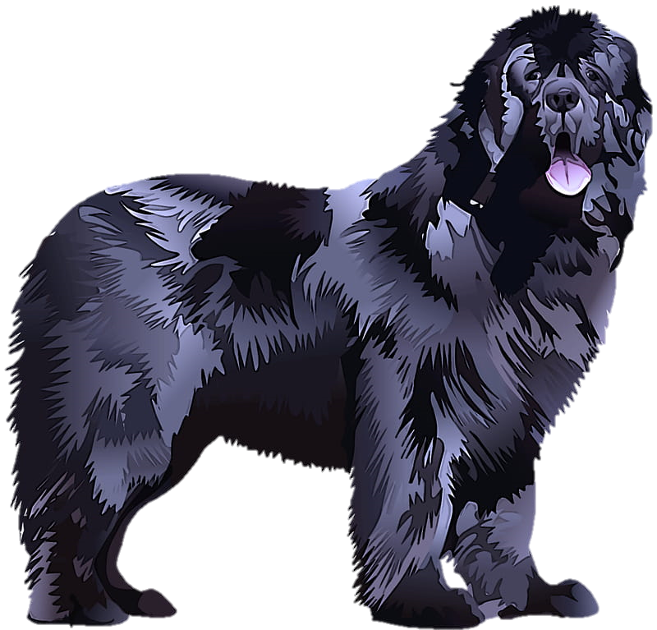

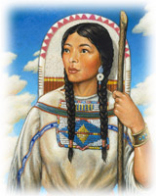

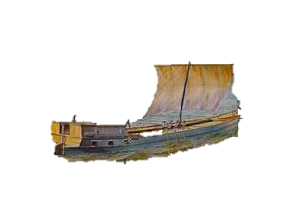

**Boats and Rivers**

Part of the mission of the Corps of Discovery was to explore the Missouri and find where it meets the Pacific Ocean. Seaman traveled by boat along different rivers throughout the expedition. Seaman and Lewis traveled down the Ohio River from Pittsburg to meet Clark at Camp Dubois where the Mississippi and Missouri rivers join. The traveling party eventually had to leave the Missouri river and travel by land. They were able to get horses from the Shoshones Indian tribe that who they met along the journey.

I traveled with Lewis on the Ohio River to meet up with Clark and the rest of the expedition members in Missouri. We then traveled up the Missouri for as long as we could, but the river became too shallow for our boats. We traveled on horseback after that, I didn’t want to ride on a horse so I was the only one who traveled on foot. I helped Lewis and Clark find where the Missouri River meets the Pacific Ocean, I don’t think they could have done it without me!



Keelboats were large flat boats with a sail that were built before the expedition. They could carry many people and a lot of supplies.

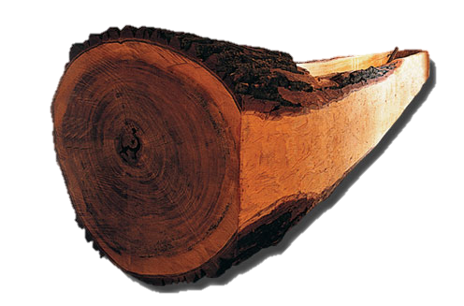

Pirogue boats were hand carved by members of the expedition when rivers got too shallow for keelboats.

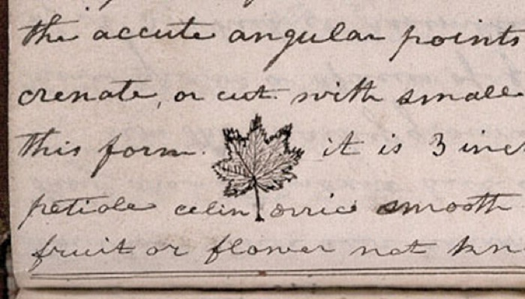

**Plants and Animals**

Part of the expedition’s mission was to study and collect plant and animal samples. There were many plants and animals in the west that were not familiar to people living east of the Mississippi River. President Jefferson wanted to learn more about what was living in the land to the west and had Lewis and Clark collect samples to send back to him to study. On their journey Lewis and Clark also studied the soil, water, minerals, landscape, weather, vegetables, and trees.

Since I came from Pittsburg, Pennsylvania there were many plants and animals I had never seen before when we traveled west. I helped Lewis and Clark catch animals for them to send back to President Jefferson. I especially liked to chase after deer and antelope and swim after beavers in the streams and rivers. I saw Lewis and Clark collect a lot of plants too, many of them were new to all of us. I saw them draw some of the plants and animals in their journals and when we returned from our journey they had artists draw some of the plants and animals by describing them.

Sketch of a Maple Leaf by Meriwether Lewis, 1806. *Courtesy of the American Philosophical Society library.*



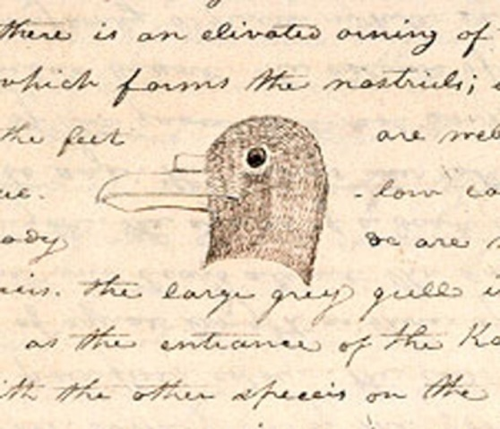

Sketch of White Gull by Meriwether Lewis, 1806. *Courtesy of the American Philosophical Society library*

**Activity #1**



**Activity #2**

What is your favorite animal? Describe that animal to someone (a sibling, friend, teacher, or parent) and see if they can guess what it is from your description.