**What Did Seaman Taste?**

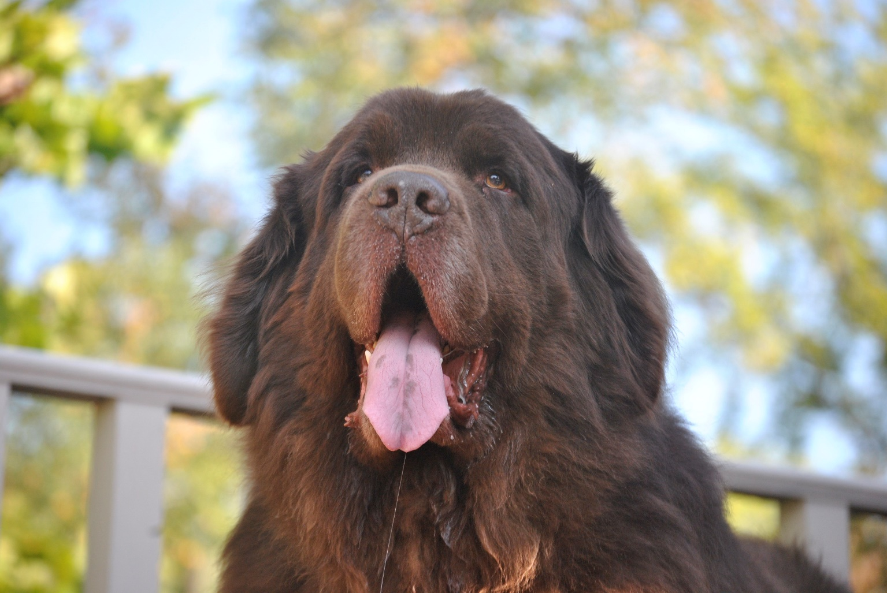

**Meat**

Since Seaman was a great hunter he played a big role in making sure the members of the expedition had food to eat. Lewis and Seaman were usually with the hunting party who went out in search of food. Lewis, or another hunter, would wound an animal with their weapons and Seaman chased after it and brought it back. Sometimes Seaman hunted all on his own. They hunted deer, bison, beaver, squirrel, and many other animals including catching fish.

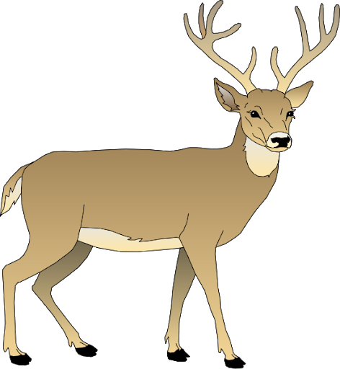

I was really good at hunting antelope, deer, beaver, squirrels, and many other animals. One time I jumped in a river to catch a beaver injured by one of the hunters. The beaver bit my leg so bad Lewis thought I was going to die. He was able to stop the bleeding and save me. That didn’t stop me from hunting though!

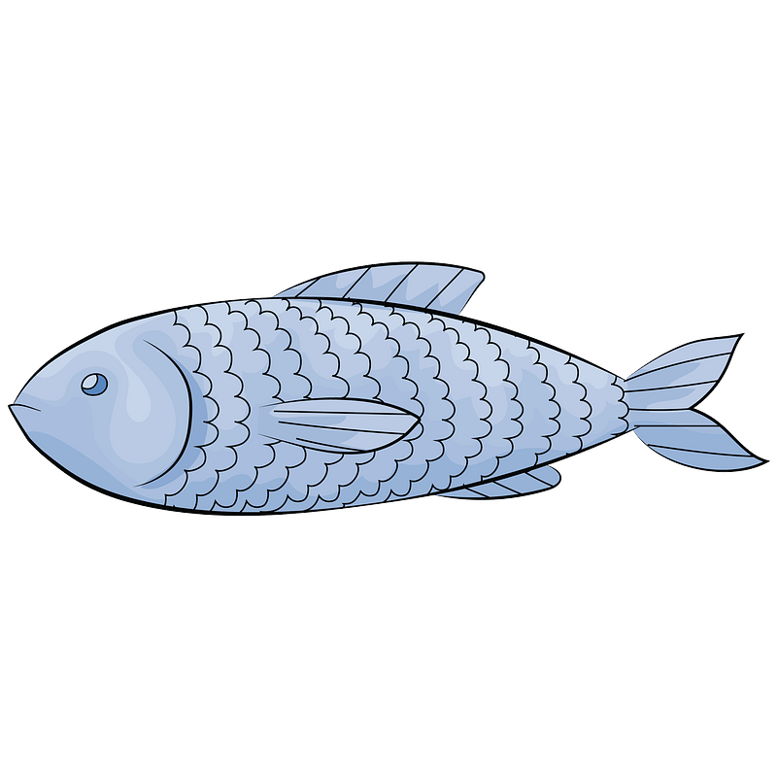

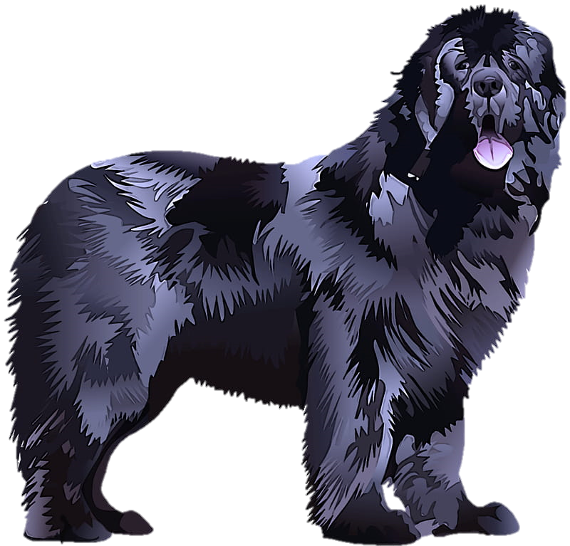

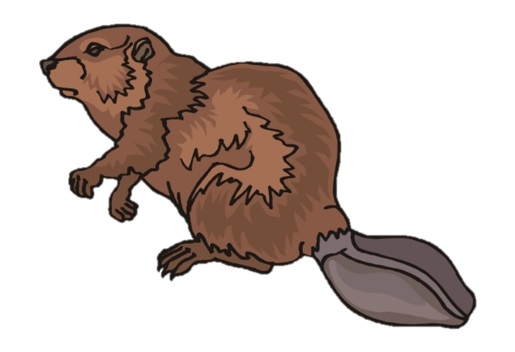

**Dry Goods**

Besides hunting for meat, Lewis and Clark brought with them 7 tons of dry goods to include flour, salt, coffee, pork, meal, corn, sugar, beans and lard.

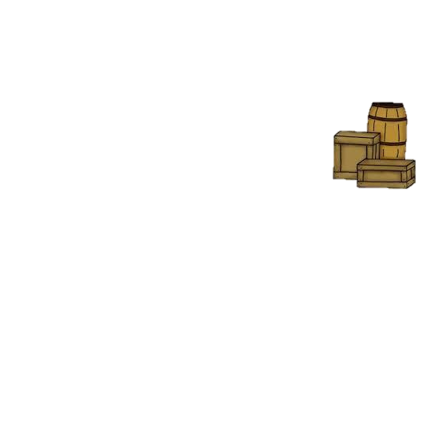

I usually ate what I was able to catch while hunting, but I did like getting some of the scraps from the dinners the men cooked over the fire. Meat was the main food source for us all because it gave us the strength we needed to keep traveling, but the men took turns cooking with the flour and salt and added different meats and beans to their recipes. Have you ever cooked something over a fire? What was it like? Did it take a long time?



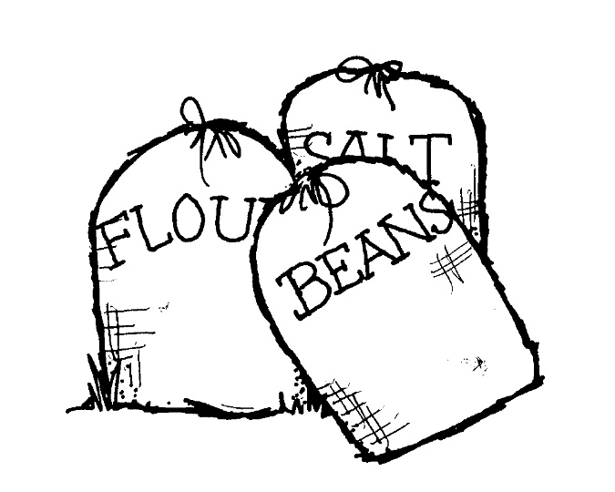

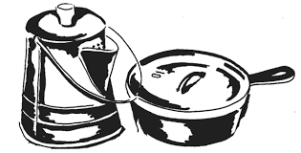

**Food From Native Americans**

Lewis and Clark brought along goods that they traded for food from the Native Americans they met. Native Americans provided squash, beans, corn, and prepared meat. They learned about edible berries, fruits, and roots they could find. Sacagawea was able to locate edible plants for the travelers too.

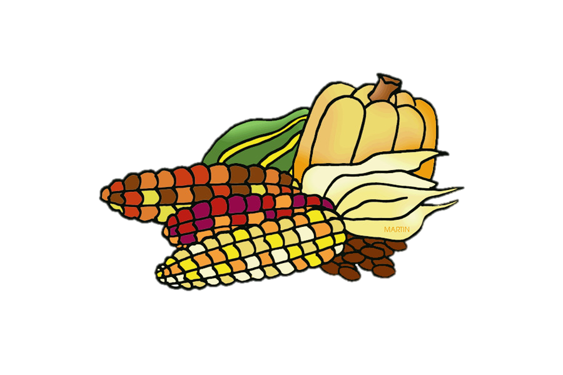

It’s amazing what the earth can provide for us and Native Americans were experts at growing food in the ground and finding things in nature that we could eat. Sacagawea, who travelled with us found edible plants for us to eat such as wild onions, currants (they are a lot like raisins), and licorice (the root of this plant is edible).

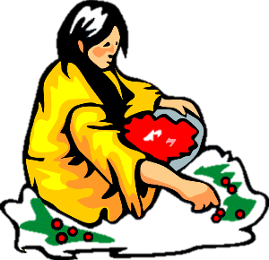

**Activity #1**

What is your favorite food? Describe how it looks, its texture (what it feels like), and what it tastes like. Why is it your favorite food? Write all of this in your journal.

**Activity #2**

Lewis described one meal that was enjoyed by the members of the expedition and Native Americans who tried it. In his journal he wrote that he experimented with a mixture of cooked flour and berries. This was something they all liked to have for breakfast and Seaman probably enjoyed it too. Many people compare it to what we now call cobbler. Below is a recipe for a berry cobbler. Lewis and Clark would have cooked their cobbler in a pot over a fire, but you can you your oven. See if you can make this berry cobbler with your family!

**INSTRUCTIONS:**

* Preheat oven to 350 degrees. Spray a 9×13 pan with nonstick cooking spray.
* In a medium-size mixing bowl, toss berries with lemon zest and juice, cornstarch, vanilla, and white sugar. Spread them out in the 9×13 pan.
* In a large mixing bowl, stir together flour, powdered sugar, baking powder, and salt. Use a pastry cutter to cut in butter until it resembles a course meal, or pulse the whole thing together in a food processor.
* Pour in half and half and stir to form a thick batter.
* Scoop the batter in large clumps on top of the berries to form a nice cobbler crust.
* Bake in the preheated oven for 1 hour.

**INGREDIENTS:**

* 3 pounds fresh berries cleaned and sliced
* 1 lemon zested and juiced
* 2 teaspoons cornstarch
* 1/2 teaspoon vanilla extract
* 1/3 cup white sugar
* 2 cups all-purpose flour
* 3/4 cup powdered sugar
* 1 tablespoon baking powder
* 1 teaspoon salt
* 1/2 cup cold butter diced
* 1 cup half and half