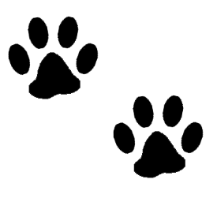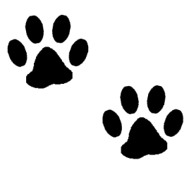

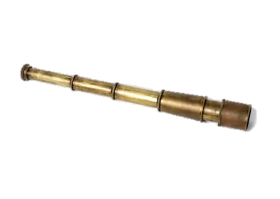

**How Did Seaman Navigate?**

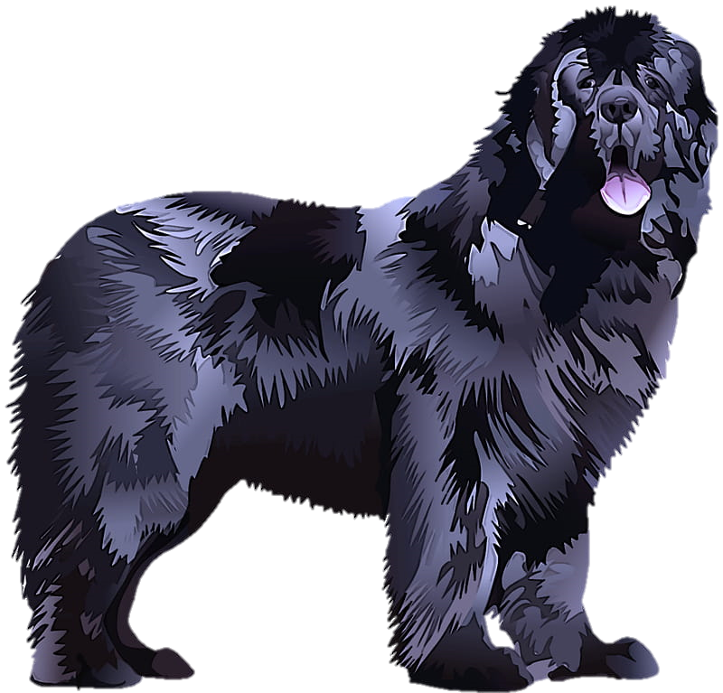

**With his nose!**

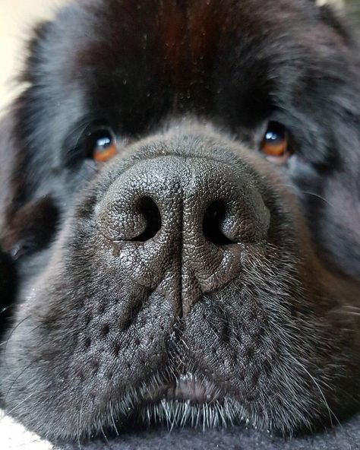

Seaman was able to sniff out danger and animals, and he could always find his way back to camp. A dog’s most important sense is smell, they use their noses to recognize friends or when a stranger is near, to hunt or track other animals, and to find their way back home.

**Activity**

Step outside or explore around your house, find three things that you can smell. Describe what they smell like in your journal! Are they stinky? Do they smell good or sweet?

**Our Sense of Smell**

Seaman used his nose to navigate and smell scents, humans mainly use our noses for smelling. Step outside or explore around your house, find three things that you can smell. Describe what they smell like in your journal!



**How Did Lewis and Clark Navigate?**



**With Scientific Tools**

**Sextant**

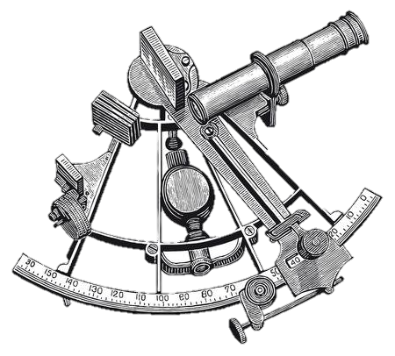

An instrument used to sight stars or the sun to find what angle and distance they are from the earth. This allows for the recording of latitude (the distance North and South of the equator). This helped explorers to make maps.

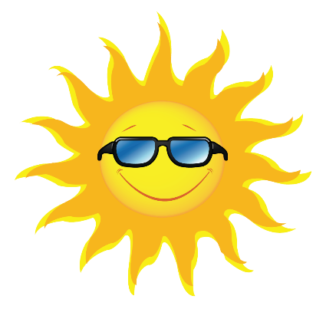

A sextant could be used during the night or by day because it had tinted lenses, like sunglasses!



Record your answers in your journal!

**What can the sun tell us?**

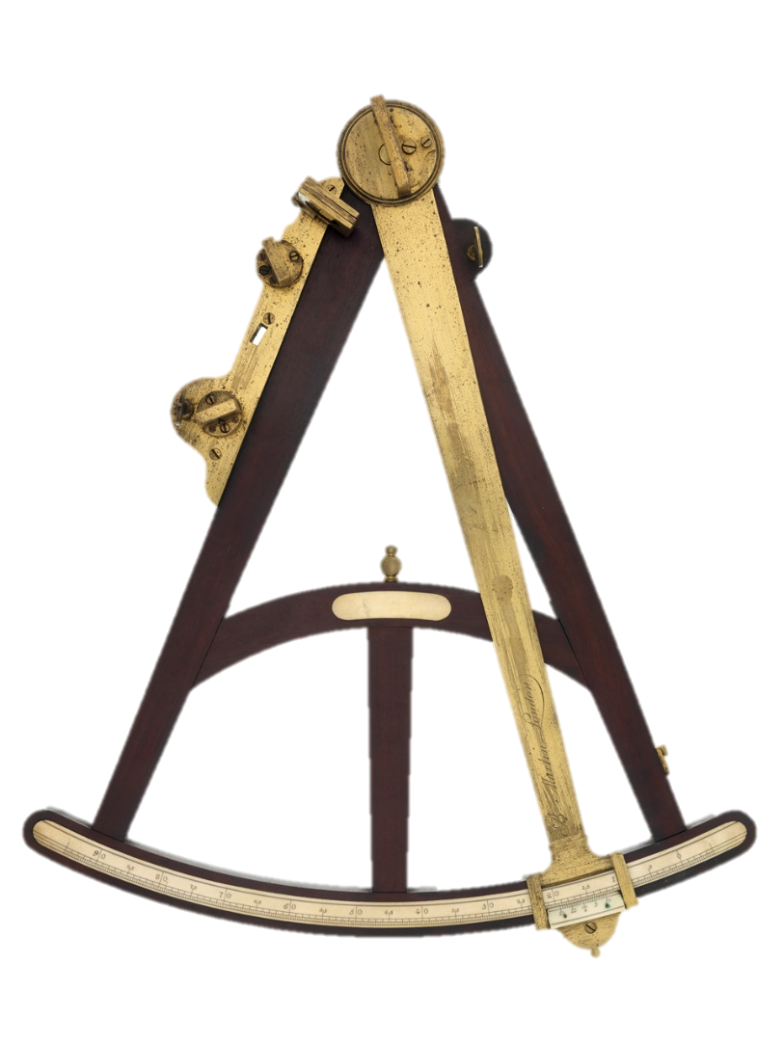

**Octant**

The octant and sextant look very similar. A good way to tell the difference between the two is that since the octant is just one part of eight pieces to a circle it is like one tentacle from an octopus, because an octopus has eight tentacles. Also the octant was first used when traveling by sea which is also where an octopus is found!

An octant, much like the sextant, was used to find latitude by measuring the angle of a star above the earth’s horizon. An octant was used mainly during the night and was first used while traveling by sea.

The octant represents 1/8th of a circle, meaning that 8 octants would form a circle if placed next to each other.

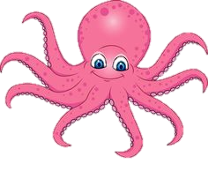

**Activity**

In your journal draw a circle, then draw lines inside the circle that divide it into 8 even pieces.

Color in one piece of the circle. That equals 1/8th of the circle, which is what an octant is!

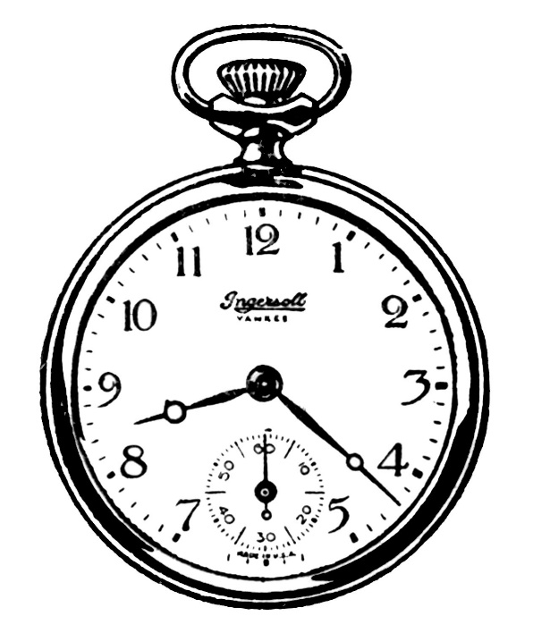

**Box/Pocket Chronometer (watch)**

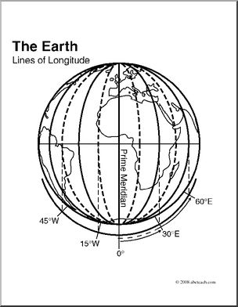

Instruments used to tell time and to measure longitude (*Imaginary lines on a globe that show distance from the Prime Meridian.)* This helped explorers to make maps.

Explorers preferred the pocket chronometers for rough travel.

Record your answers in your journal!

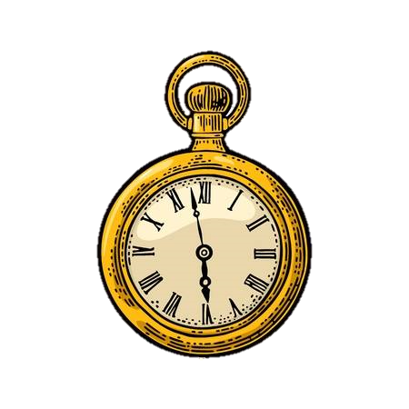

**Why is it important to tell time when travelling?**

**Surveyor’s Compass**

A surveyor’s compass was placed on a stand with three legs and was used to find the direction of north.

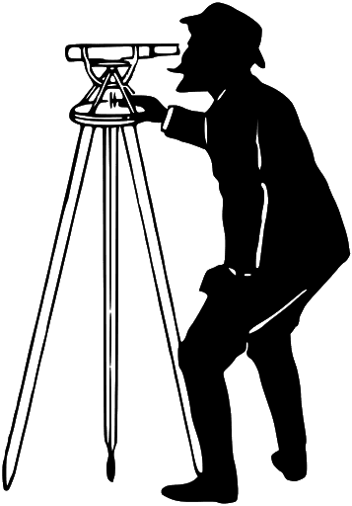

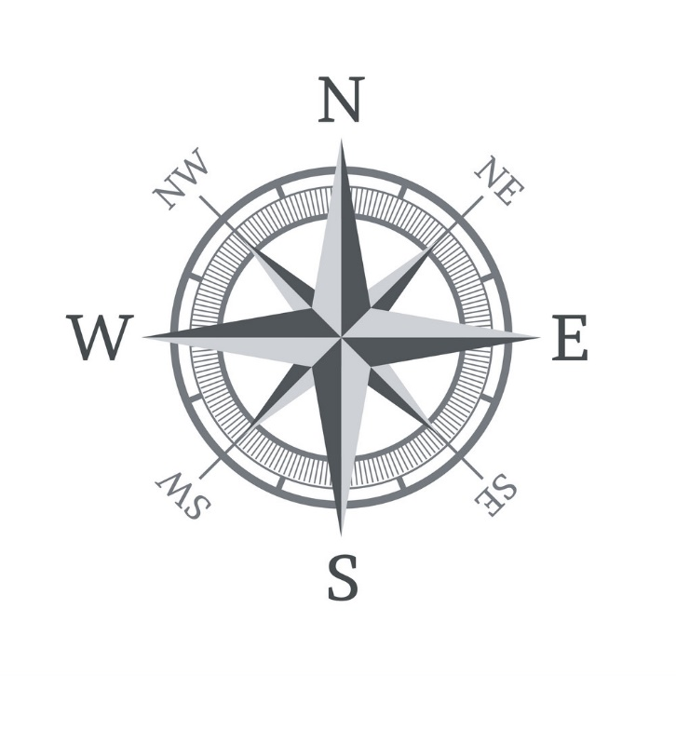

**Maps**

Lewis and Clark used all these pieces of equipment to make maps of the land they explored. Longitude and latitude (mentioned above) were important for map making. Longitude and latitude formed grid lines that helped Lewis and Clark mark important areas on their maps.

**Map Activity #1**

Complete the longitude/latitude worksheet provided.

**Map Activity #2**

In your journal make a map of the room you are in or an area outside, like your back yard!

What to include on your map:

1. Draw what shape you think the room is in (rectangle, triangle, circle, etc.)
2. Mark big areas of the room, such as a large structure or feature.
3. Feel free to color your map!