DEPARTMENT OF THE ARMY
THE U.S. ARMY cENTER OF MILITARY HISTORY
102 4th AVENUE
FORT LESLEY J. McNAIR, DC 20319-5060
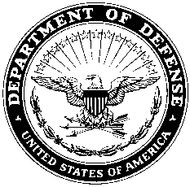

AAMH-MD XX XXX XXXX

MEMORANDUM FOR Director, US Army Center of Military History

SUBJECT: Request for Exception to Policy for a Volunteer

1. Reference: AR 870-20, Army Museums, Historical Artifacts and Art, 11 January 1999, Paragraph 3-12, Volunteer Programs.

2. Request for exception to policy to allow _____________ to work as a volunteer at the __________________ Museum.

3. Mr./Ms. _______________________ will be performing duties related to cataloging artifacts and for this, requires access to the Army Historical Collection Accountability System (AHCAS). Request approval for ______________ to gain access to AHCAS and work with Army artifacts under the direct supervision of an assigned museum staff member.

4. The POC for this action is ____________________, xxx-xxx-xxxx or email: _________________.civ@mail.mil.

Encls: ____________________________
(1) Resume Director
(2) Approval Memo ___________________Museum

